Sri Lanka Institute of Information Technology


IT1040 - Fundamentals of Computing
Year 1, Semester 1- 2024

<Greenhouse Automation System>

Progress Report
<P12 - 19>

IT Number | Name
IT24102366 | Wittahachchi S.D
IT24100612 | Manvindu R.A.T.
IT24101116 | Jayasinghe J.A.D.T.N.
IT24102565 | Chamodya A.L.A.K.
IT24102088 | Maduwatta U.S.T.
IT24101036 | Seekkubadu C.R.

- Introduction
Automated Greenhouse System that can detect Soil moisture, Environmental temperature and Light intensity. And depend on those parameters our output devices ( water pump actuator, cooling fan actuator and Artificial sunlight light actuator) will provide a perfect environments to the greenhouse. Also these parameters can be displayed on a mobile application.

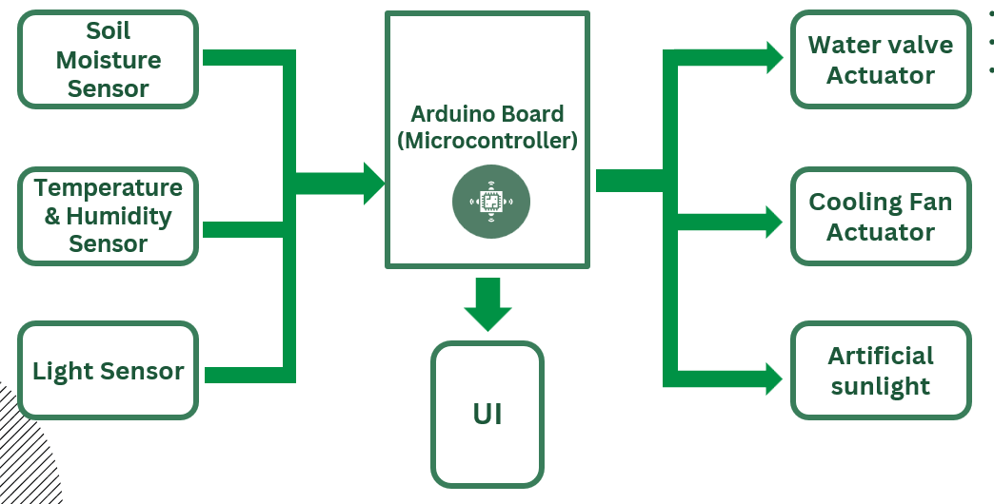
- System Architecture

- For the connection we are using a breadboard and jumper wires( M2M, M2F, F2F)
- Including ESP8266 Wi-Fi module for connect the IoT System to a mobile application UI.
- Connect those above mentioned Inputs and Outputs to the Arduino board according to the system diagram.
- LED for represent the Artificial Sunlight actuator.
- “Remote XY” Software to provide mobile UI.

- Work Breakdown Structure

- Proof of Work

- Required components
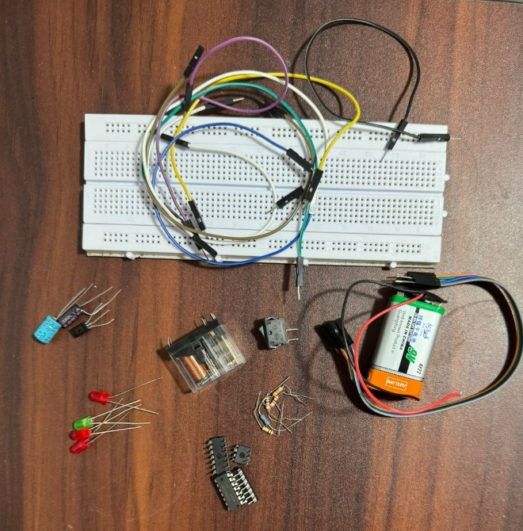
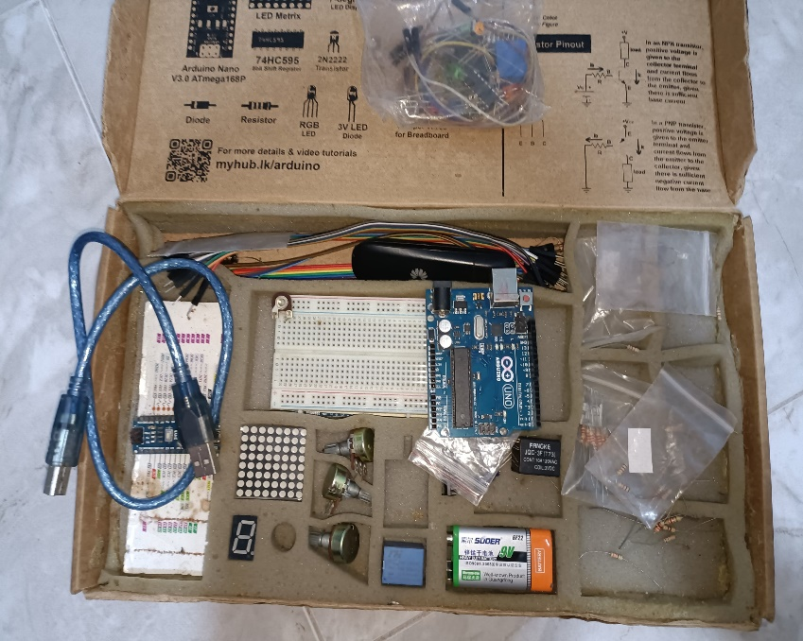
- System Diagram
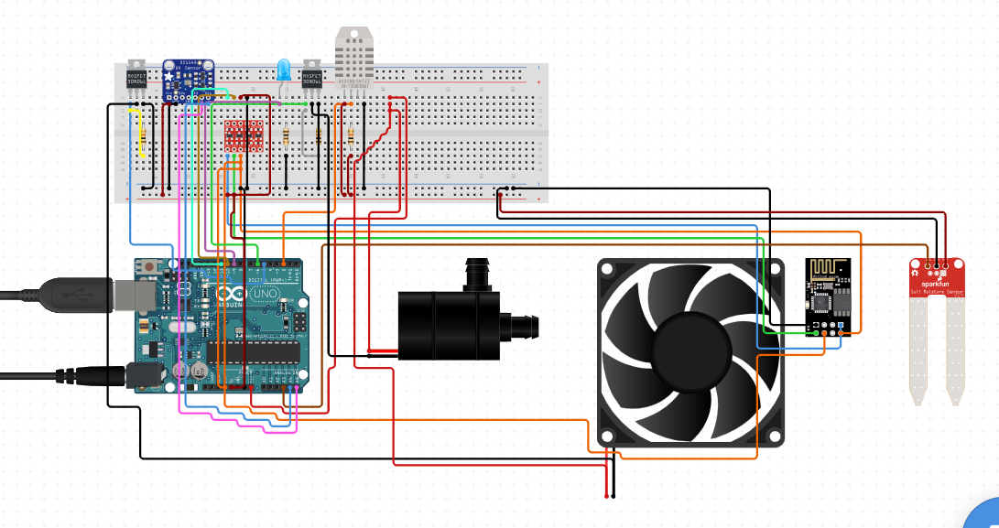

- Programming the Arduino board
